1.Vehicle Rental Database

2.Upload Vehicle Data

3.Search a Vehicle

4.View Vehicle Details

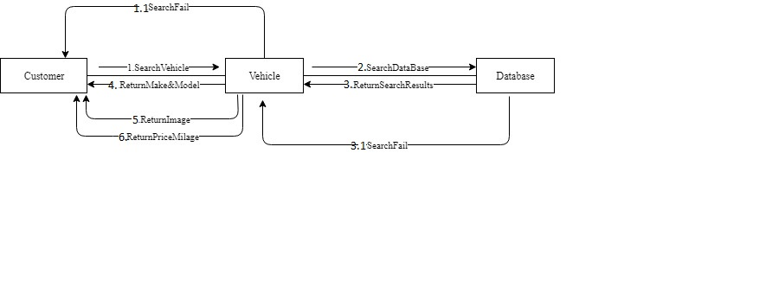5. Search Passenger Capacity

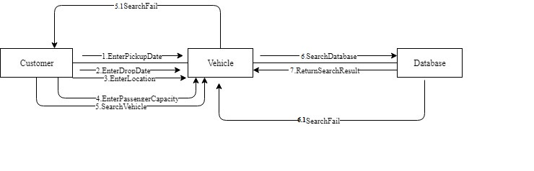6.Search Price Range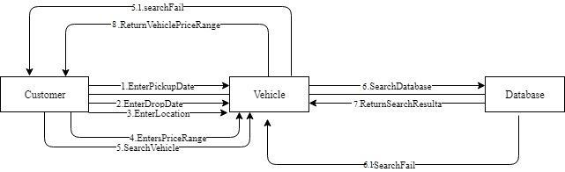7. Search on Vehicle Type

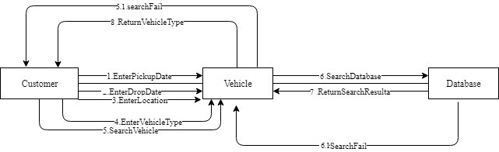8. Search on Transmission Mode

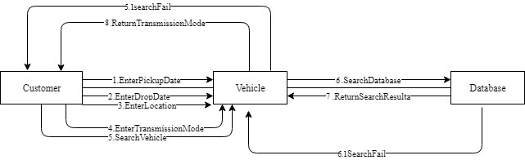

9. Register an Account

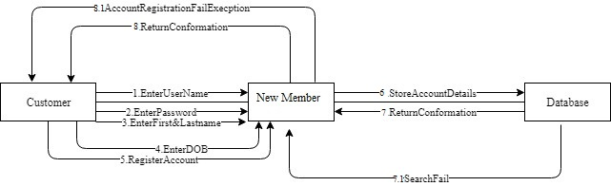10.Login to Account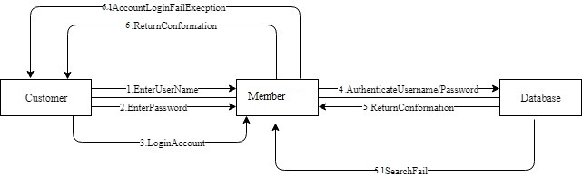

11.View Bookings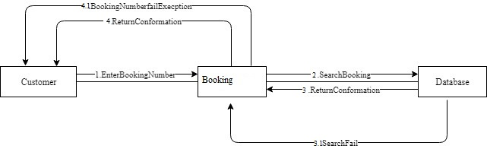

12.Filter on Average Customer Rating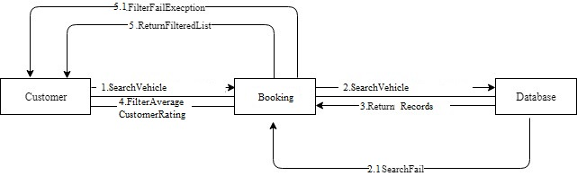

13.Filter on Price Range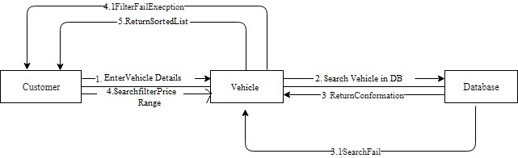14.Vehicle Pick-Up Locations15.Drop Vehicle at Home16.Bolling For Vehicle Booking 17.Recipt of Booked Vehicle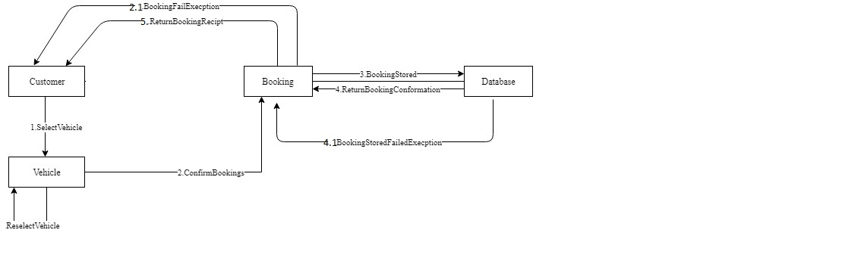18.Adding Additional Drivers With Insurence19.Print recipt of booked Vehicle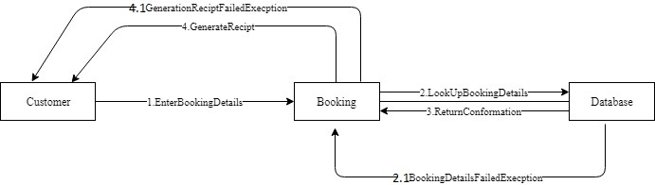

20.Upgrade existing booking21.Assign privilages to customers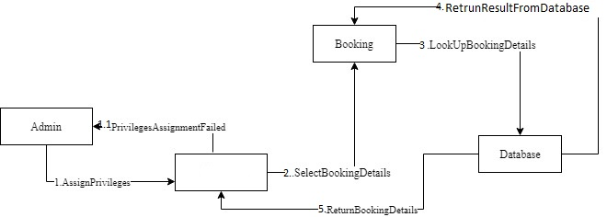

22.Search with voice recognisition 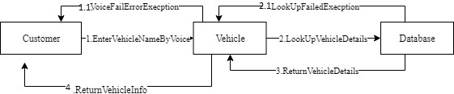

23.Modify future boking

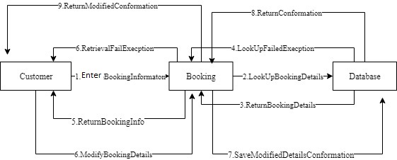

24.Cancle Future Booking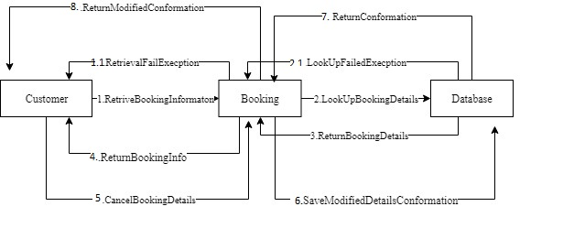

25.Provide Insurance details

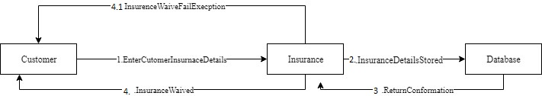

26.View Terms and Conditions

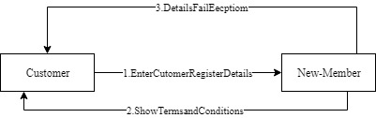

27.Choose a Language

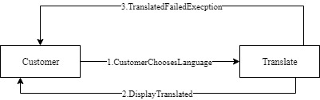

28.Rent a Vehicle for long Term

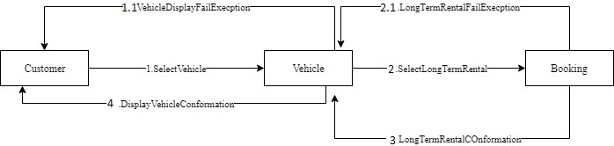

29.View Reward Points

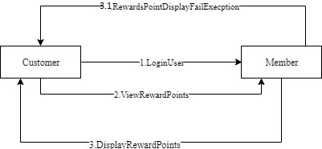

30.Rate and Review

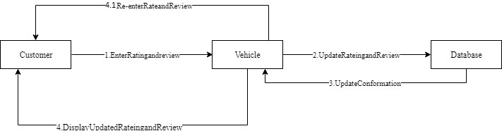

31.Choose additional accessories

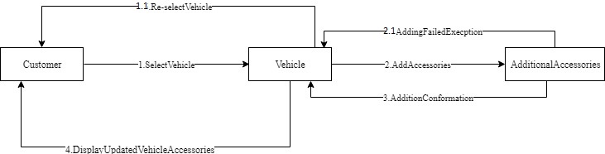

32.Pick-up/Drop-off Location

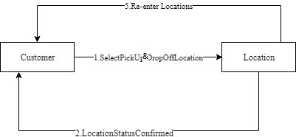

33.Access to Reports

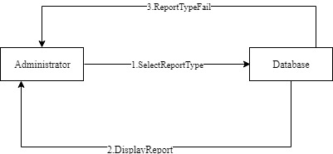

34.View special rates

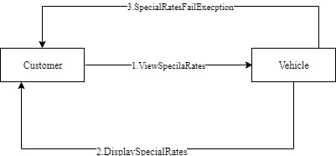

35.Manage Memberships

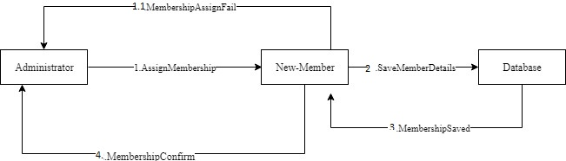

36.Access to Driving records

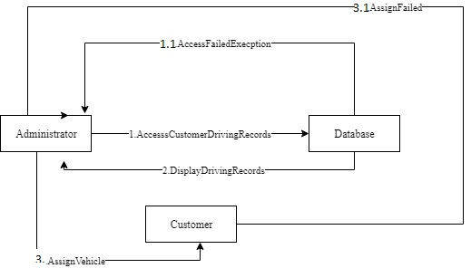

37.Redeem reward points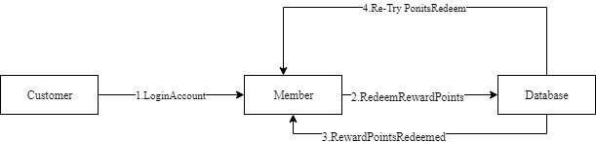

38.Navigate Pick-up Location

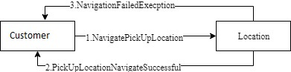

39.Provide Customer Benifits

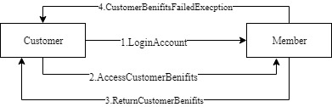

40.Provide Family Benefits, Promotions, Redeem membership Points

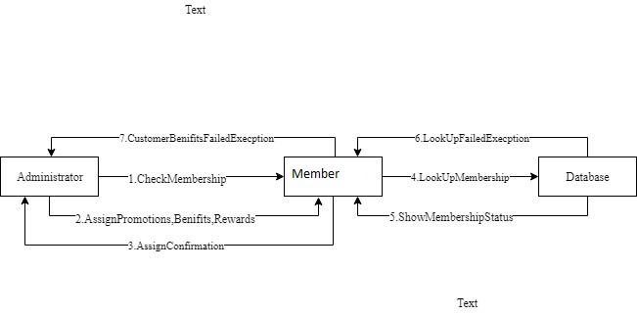

41.Administrator should provide proper Encryption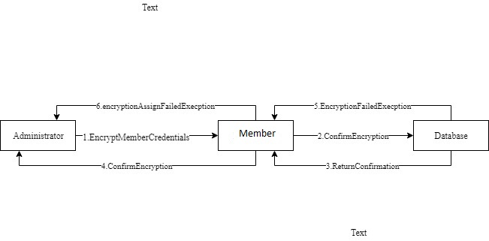

42.Choose Calendar days

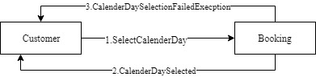

43.Customize Payments

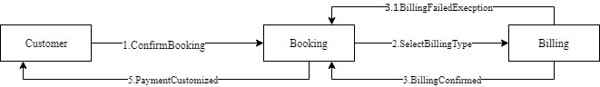

44.Payment through Paypal

